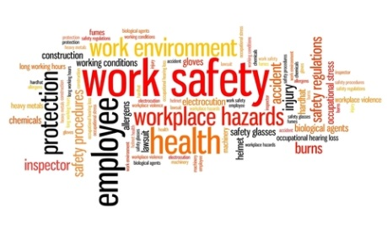

THE PURPOSE OF THE SAFETY COMMITTEE

The purpose of the Safety Committee is to bring workers and management together in a cooperative effort to promote safety and health in each work place. A Safety Committee helps the employer and makes recommendations for change regarding occupational safety and health issues.

Objective:

- Provide a safe and healthy educational environment for the student population
- Provide a safe and healthy work place for each employee
- Provide a safe facility for the public
- Reduce property, liability and workers’ compensation losses
- Promote awareness and focus attention on safety issues
- Provide safety communication channels from school/site, and from school/site to employees

Legal Requirements:

Senate Bill (SB) 198 requires the employer to document its system for communicating with
employees on occupational health and safety matters, including provisions designed to encourage
employees to report hazards without fear of reprisal. Article VII of the Bylaws of the Schools
Insurance Program for Employees (SIPE) requires that all members’ agencies have a functioning
safety committee.

Criteria for Compliance:

SB 198 contains certain minimum requirements for Safety Committees. For the district to be
considered in compliance with the communication requirement, the committee must be
empowered to:

- Review the employer’s periodic, scheduled worksite inspections
- Review investigations of causes of incidents resulting in injury, illness, and exposure to hazardous substance, or near-hit incidents.
- Review investigations of any alleged hazardous condition brought to the attention of any committee member
- Conduct inspections and investigations when determined necessary by the committee

Information provided by the SIPE Safety Committee Manual

